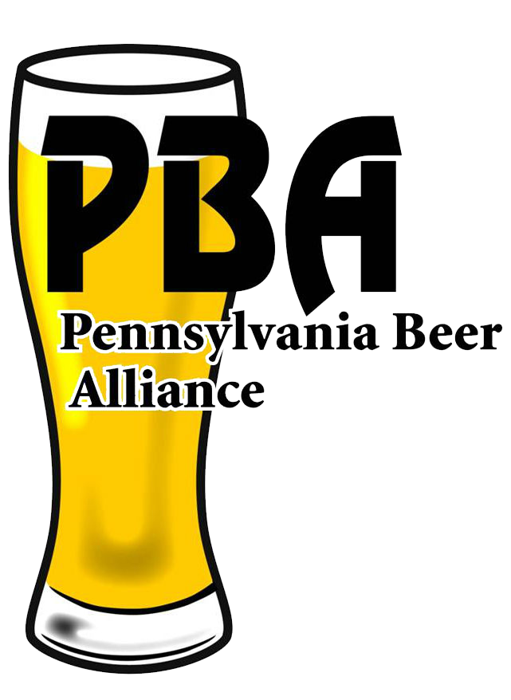

PENNSYLVANIA BEER ALLIANCE MEMBERSHIP APPLICATION
600 NORTH 3RD STREET, SUITE 100 HARRISBURG, PA 17101
WWW.PABEER.COM

Please print or type information requested.

Company Name: ____________________________________________________________________

d/b/a (if applicable): __________________________________________________________________

Street Address: ____________________________________________________________________

City/State/Zip Code: _________________________________________________________________

Mailing Address (if different): __________________________________________________________

City/State/Zip Code: _________________________________________________________________

Telephone: _____________________ Cellphone: ____________________ Fax:_________________

Email: _________________________ Website:______________________

CONTACTS: TITLES/EMAIL ADDRESSES
1. ______________________________________________________________________________
2. ______________________________________________________________________________
3. ______________________________________________________________________________

BREWERIES/IMPORTERS RESPRESENTED:
o ABI o Miller Coors o Constellation Brands o Diageo Beer Company USA o Heineken USA
o Pabst o Yuengling o Other: _____________________________________________________

MAJOR BREWER OR IMPORTER: __________________________________________________

OTHER PRODUCTS DISTRIBUTED (Check all that apply):
o Bottled Water o Soft Drinks o Hard Lemonade o Hard Cider o Juices
o Coolers o Energy Drinks o Other: ________________________________________________

- OVER -

ECONOMIC MODEL INFORMATION:
Year business was founded ..... ____________________
# of cases sold per year ……… ____________________
# of employees ………………... ____________________
# of delivery trucks ……………. ____________________
State Excise taxes paid ……. $ ____________________
Local Excise taxes paid ……. $ ____________________

REGULAR MEMBER DUES FORMULA
(To compute your company’s dues payment, please apply the formula below.)

$475 per $1 Million Annual Beer Sales

Maximum Amount: $75,000
(sales of $157,894,737 or greater)

Minimum Amount: $2,103.29

.000475 x $____________________ = $____________________
Annual Beer Sales Total Amount Enclosed

Under the Federal Omnibus Reconciliation Act of 1993, lobbying expenses are not deductible as ordinary business expenses. P.B.A, must estimate the percent of dues which will be expended for lobbying and notify our members of the portion of their dues which are non-deductible. For the membership year, P.B.A. estimated that the non-deductible portion of dues is 14%.

Dues are payable and cover membership from January 1st through December 31st. In order to avoid suspension of privileges and voting rights, dues must be received by April 1st. Please make your check payable to: “Pennsylvania Beer Alliance”

Please forward your check and one copy of this statement to:

PENNSYLVANIA BEER ALLIANCE
600 NORTH 3RD STREET, SUITE 100
HARRISBURG, PA 17101

I verify that all the information given on this application is correct to the best of my knowledge and that the appropriate dues payment is enclosed.

____________________________________________________ _______________
Signature Date

