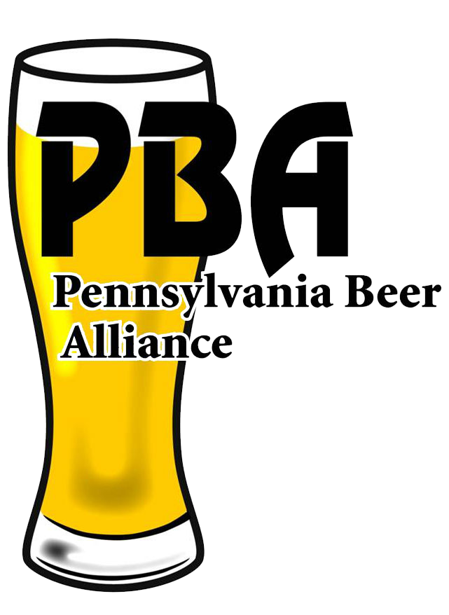

PENNSYLVANIA BEER ALLIANCE ASSOCIATE MEMBERSHIP APPLICATION
600 NORTH 3RD STREET, SUITE 100 HARRISBURG, PA 17101
WWW.PABEER.COM

Please print or type information requested.

Company Name: ____________________________________________________________________

Street Address: ____________________________________________________________________

City/State/Zip Code: _________________________________________________________________

Telephone: _____________________ Cellphone: ____________________ Fax:_________________

Email: _________________________ Website:______________________

CONTACTS: TITLES/EMAIL ADDRESSES
1. ______________________________________________________________________________
2. ______________________________________________________________________________

TRADE MEMBERS (2019 SALES – 31 GAL. BARRELS):
o $4,500 (10 Million Barrels and above)
o $2,500 (1 – 10 Million Barrels)
o $1,300 (500,000 – 1 Million Barrels)
o $750 (25,000 - 500,000 Barrels)
o $275 (Under 25,000 Barrels)

NON-TRADE MEMBERS:
o $400

Dues are payable and cover membership from January 1st through December 31st.
Please make your check payable to: “Pennsylvania Beer Alliance”

Please forward your check and one copy of this statement to:

PENNSYLVANIA BEER ALLIANCE
600 NORTH 3RD STREET, SUITE 100
HARRISBURG, PA 17101

Under the Federal Omnibus Reconciliation Act of 1993, lobbying expenses are not deductible as ordinary business expenses. P.B.A, must estimate the percent of dues which will be expended for lobbying and notify our members of the portion of their dues which are non-deductible. For the membership year, P.B.A. estimated that the non-deductible portion of dues is 14%.

